THIS my portfolio colour combination..

URL: https://youtu.be/Tkp3FDgOueM

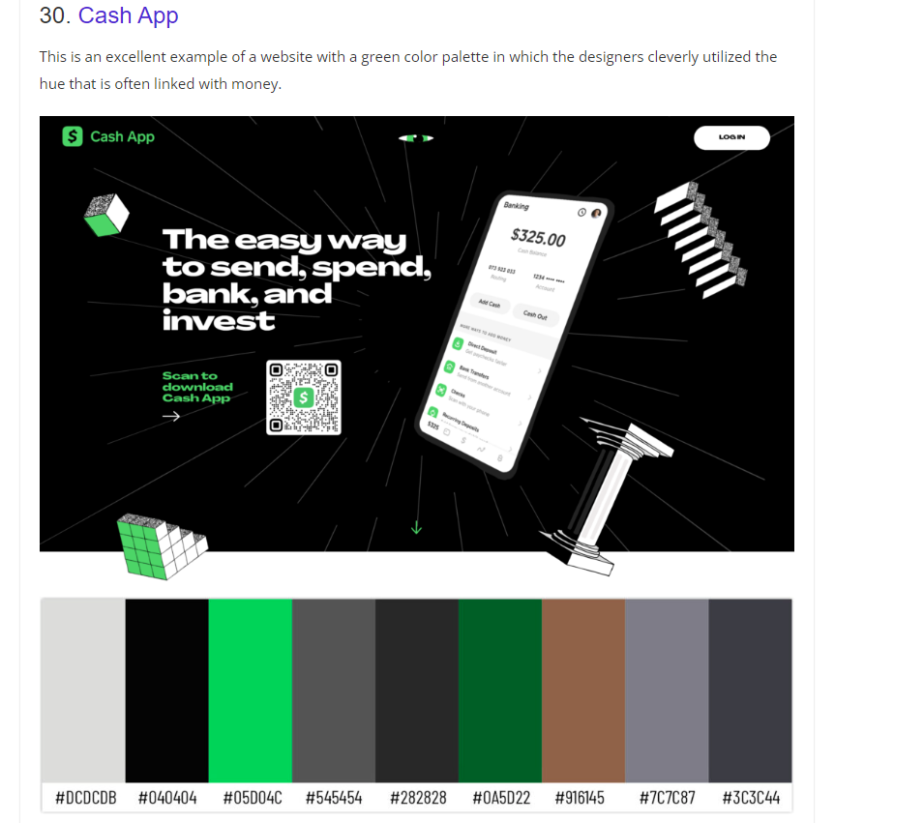

:root{

    --bgblack:#040404;

    --primary:#05D04C;

}